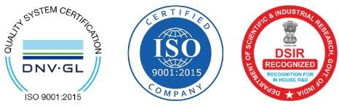

Test Requisition Form – Microbial Identification
(Kindly send the order form along with the samples)

From: Billing Information:

Note: Highly sensitive techniques of PCR and Sequencing will be involved in this work, the accurate identification depends on the purity of the culture. Please enquire for purification of mixed cultures.

Mode of Sample shipment:

Test Required: Bacterial (16SrRNA complete/partial) / Fungal (ITS1&4):

1
2
3
4

SAMPLE DETAILS:

S. No | Sample Name/ ID | Type of Culture | Pathogenic/Non- Pathogenic | Report Type (Complete/Partial)

Culture Requirements
Culture should be pure (only 1 type of micro-organism in the plate). Should not be overgrown.
Broken/cracked petri dishs/slants are not accepted. Fungal samples are accepted in petri dish only.
Culture plates/Broth cultures(15ml falcon tubes) should be tightly packed & wrapped in para film.
Pathogenic cultures must be labelled appropriately.

NOTE:

FOR LAB USE
Sample Receipt Date
Sample Registration No.
Total No. of Samples received
Results sent
Other Information


Results:
- Complete Service includes basic phylogenetic analysis and reporting of the identified organism
(Complete: DNA isolation, PCR product generation with Bi-directional Sanger Sequencing Chromatograms, Analysis, Reporting)

- Partial service includes only raw sequencing data.
(Partial: DNA isolation, PCR product generation with Bi-directional Sanger Sequencing Chromatograms, Raw File)

- Detailed Bioinformatic analysis can be offered at an extra charge.
- Reporting Timeline: 7-8 Working days.
- Any repeat requests will be taken up withing 1 month of data/ report sharing.

